Technology Certification:
OEM Memorandum of Agreement
Product brand: | Brand name
Document version date: | 2023-11-07

Notice
Copyright © 2023, SITA SOC Ltd (Registration No: 1999/001899/30). All rights reserved. No part of this document may be reproduced or transmitted in any form or by any means without the express written permission of SITA SOC Ltd.

Document enquiries may be directed to:
Records Management Office
SITA SOC Ltd
PO Box 26100, Monument Park, 0105, South Africa
Tel: +27 12 482 3000
www.sita.co.za

Technology Certification: OEM Memorandum of Agreement
Document No: eIRPL-00002
Version: 2.3
Author: Izak de Villiers, izak.devilliers@sita.co.za, +27 12 482 2749

Approval
The signatories hereof, being duly authorised thereto, by their signatures, hereto authorise the execution of the work detailed herein, or confirm their acceptance of the contents hereof and authorise the implementation/adoption thereof, as the case may be, for and on behalf of the parties represented by them.

Tshavhu Mukhodobwane  HOD: Norms Standards and Quality |  | Date
Signatory Name  Signatory Capacity, Organisation name |  | Date

Contents
1. Introduction 4
1.1 Aim 4
1.2 Scope: Technology domains 4
1.3 References 6
1.4 Applicability and Exclusions 6
1.5 Confidentiality 7
2. Guidelines for completion of MoA 8
3. Brand and contact details 9
4. MoA requirements 10
4.1 Legal status of OEM or brand representative 10
4.2 OEM participation 10
4.3 Manufacturing standards 12
4.4 OEM product selection 13
4.5 Technology evaluation process 13
4.6 After-sales support 15
4.7 Technical requirements 16
Abbreviations, Terms and Definitions 18
A.1 Abbreviations 18
A.2 Terms and Definitions 19

Tables
Table 1: Technology domains within the TCP 5
Table 2: Brand, contact details and tech domains 9

Figures
Figure 1: e-Government House of Value 4
Figure 2: MoA Applicability 5
Figure 3: Requirements for supply to Government 7

Introduction
In terms of the SITA Act and National Treasury Practice Note 5 of 2009, “SITA must conduct a standard certification in respect of ICT goods and/or services before finalising a list of prospective suppliers”. To support this mandate, SITA has established a Technology Certification Process (TCP) to allow manufacturers to submit their products for certification. The TCP is separate from any bid process, being a stand-alone process supporting any procurement request (RFB/RFP/RFQ) issued by Government, in line with SITA’s certification mandate. Product certification will be done solely in conjunction with manufacturers as part of the TCP.
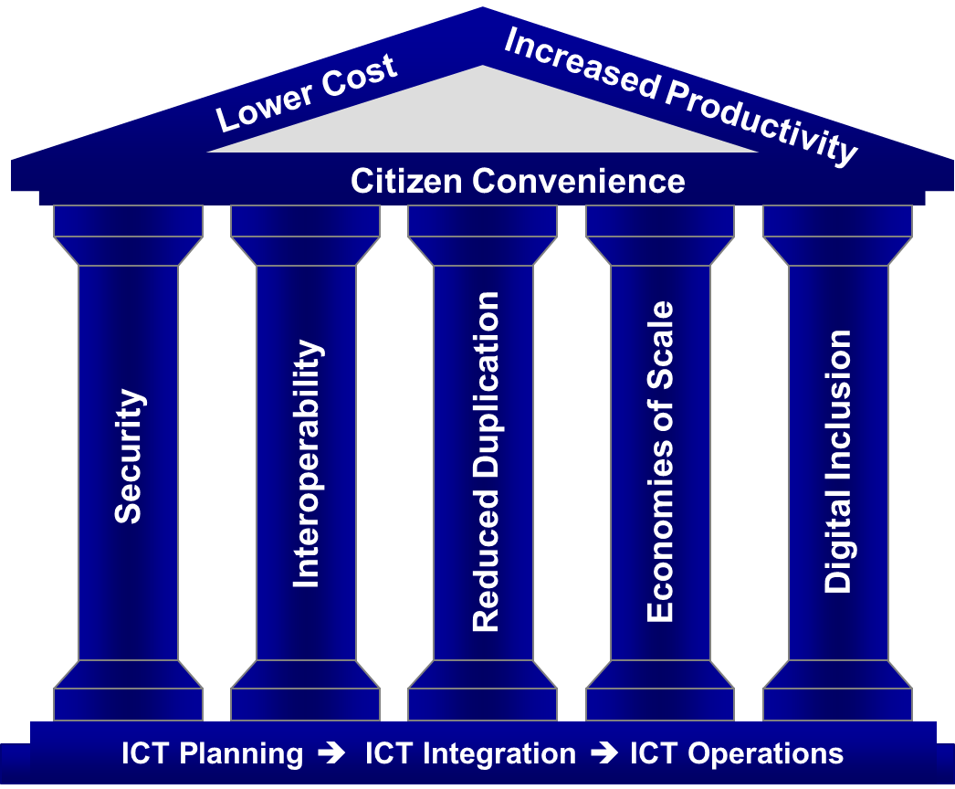
Figure 1: e-Government House of Value

This Memorandum of Agreement (MoA) guides the relationship between SITA and Original Equipment Manufacturers (OEMs) in terms of the TCP, supporting the acquisition of ICT products by Government Departments, either via transversal contracts or as prescribed by SITA and National Treasury regulations.
Any Government bids for ICT products or solutions will require product certification by SITA, whether procurement is via transversal contracts or alternative vehicles prescribed by National Treasury and SITA regulations.

Aim
The primary goal of the MoA is to ensure that OEMs support SITA’s mandate to enable procurement of standards-based, cost-effective, high-quality solutions for deployment in Government, fulfilling the requirements of the e-Government House of Value.
Once the agreement has been finalised, OEMs must follow the rest of the Technology Certification Process to certify their products, as it is not sufficient to have the brand listed with SITA. OEM products are continually certified by SITA independent of bids or tenders, but only certified products may be supplied to Government at any time.

Scope: Technology domains
The MoA provides the basis of a working relationship between SITA and registered brand representatives to support the Technology Certification Process, whereby SITA certifies products for procurement by Government. The Agreement only applies to manufacturers that represent a product brand sold to the SA Government, and that also fits into one of the identified technology domains. These domains include, but are not restricted to, the following:
Domain | Components
Personal Computing Devices | Desktop PCs, Mobile PCs, Desktop displays, Mobile devices (Tablets, Smartphones, Industrial handhelds), Accessories and Device Management
Peripherals | Printers, Multifunction devices, Scanners, Digital cameras, Automatic Data Capture (Barcoding, Card devices), Biometric readers, Optical storage (DVD duplicators), Consumables and Print management
Assistive Technologies | Assistive devices and software for people with disabilities, including smart devices (tablets, PDAs, readers, media players, recorders and braille devices), peripherals (input and output devices) , assistive software enabling access and speech (AAC), and skills development and learning aids for users with disabilities
Education Solutions | Classroom solutions, including PCs, laptops, tablets, presentation and teaching devices, Classroom infrastructure and systems (hardware and software), and e-Sports systems
Audiovisual Communications Technologies | Video and audio conferencing, large-format display devices (projectors, monitors, interactive displays and display walls), collaboration, media recording, speech processing, and AV signal control and management
Surveillance & Access Control | Fixed and mobile surveillance and physical access control solutions, including IP cameras, mobile cameras, UAVs, storage and recording devices, video management systems and control room solutions
Servers & Storage | Servers (Rack-mount, Tower, Blade), Primary storage and Secondary storage (Disk to disk, Tape automation and Archiving) and System management
Networking | LAN, WLAN and WAN equipment, Wireless backhaul, and Structured cabling (copper and fibre-optic)
Infrastructure | UPS, Equipment Racks, Alternative power, Cable ducting, trenching and routing
Cybersecurity | Cybersecurity products and solutions (ISS – information system security)
Table 1: Technology domains within the TCP

An MoA can only be entered into with an OEM if the manufacturer’s products fall within one of the above technology domains, as well as within a specific sub-category (i.e. if a Detail Specification exists for this type of commodity). Products that do not have an associated category or specification within this structure cannot be certified until such a standard has been established.
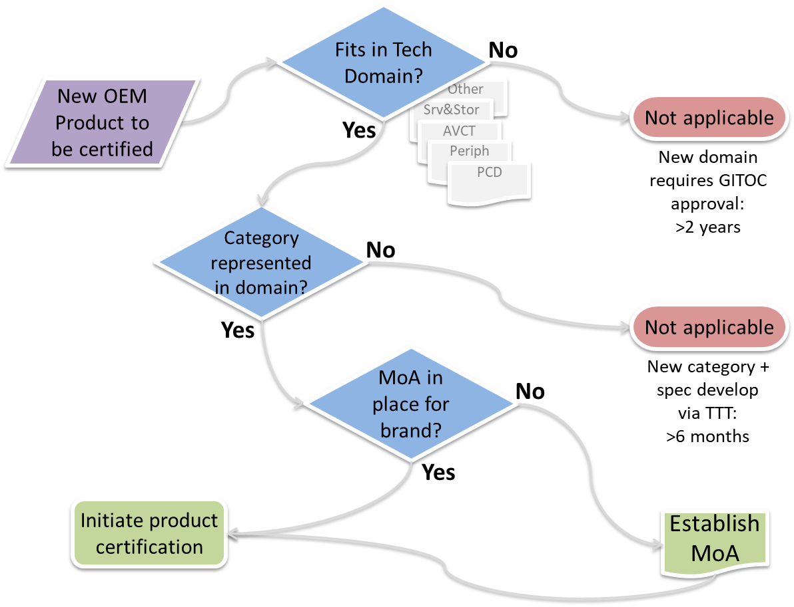
Figure 2: MoA Applicability

In the absence of a signed MoA, no products will be certified for that OEM. If an MoA lapses or is cancelled, any existing certified products will be removed from the product catalogue. Conversely, if the OEM has no products certified for an extended period, the MOA may be cancelled without notice at the discretion of SITA.
Additional technology domains will be included in the process as and when required by the Government and established via the official GITOC process.

References
- The Constitution of R.S.A., 1996
- Public Finance Management Act (PFMA), Act 1 of 1999
- State Information Technology Agency Act (Act 88 of 1998), as amended by Act 38 of 2002
- SITA Regulations, 23 September 2005
- National Treasury Practice Note no. 5 of 2009
- Minimum Interoperability Standards: www.sita.co.za/content/minimum-interoperability-standards
- Minimum Information Security Standards: www.sita.co.za/content/minimum-information-security-standards
- Technology Certification Process, version 4.0, March 2022
- Technical specifications for technology domains: SITA Product Certification website www.sita.co.za/prodcert.htm
- Latest versions of all related specifications, processes, documents and forms: www.sita.co.za/prodcert.htm
- MoA-related documents and forms:
  - Memorandum of Agreement (this document): www.sita.co.za/sites/default/files/documents/Product_Certification/OEM_Memorandum_of_Agreement_(MoA).docx
  - Checklist for MoA meeting: www.sita.co.za/sites/default/files/documents/Product_Certification/Checklist_OEM_Meeting_(MoA).xlsx

Applicability and Exclusions
This MoA is applicable to manufacturers of hardware, hardware-based solutions (e.g. virtual appliances), system management tools and specialised software (e.g. assistive applications). General software applications, operating systems and other software-based solutions are not covered by the process at present.
The Technology Certification Process excludes the following:
- SCM processes and related requirements (e.g. tax status of OEMs)
- Price and contract negotiations
- OEM and reseller agreements between SITA SCM and industry
- Agreements between OEMs, distributors and resellers
- NIPP, SMME, BEE and other related requirements
- Tender and other procurement processes

Relationship of MoA to tenders and procurement contracts
Despite the fact that an OEM representative has established an MoA with SITA, and has certified its products, this does not automatically entitle them to supply to Government via a transversal contract.
OEM partners (resellers) still need to be accredited to supply to Government via a tender process. The diagram illustrates the three separate requirements that must be met:
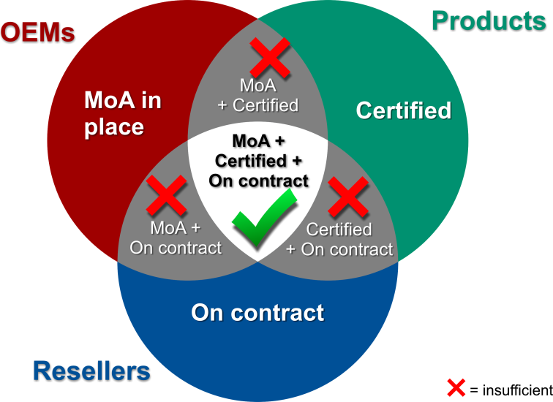
Figure 3: Requirements for supply to Government
- MoA must be established
- Products must be certified
- Resellers, partners and integrators must be accredited to supply the brand on the appropriate procurement contract.

Tender processes are usually managed by SITA’s SCM division, or by a client department in cases where an ad hoc request for bid is published.

Third-party components
The TCP is primarily designed to certify stand-alone ICT products or solutions. Accessories or components, either from the OEM or from third-party suppliers, when bundled with the certified solution, are complementary and are certified as part of the complete solution.
Any bundled or optional components or add-on software (e.g. upgrades, accessories, connectivity, operating systems, software tools, drivers) are therefore deemed to be automatically certified when an OEM offers these components as part of a certified solution. These components therefore do not need to be directly certified via the TCP, as they are offered as part of an OEM’s certified product or solution.
In certain domains, however, provision is made for third-party accessories or components: e.g. the Accessories category in PCDs, or the Consumables category in the Peripherals domain. In these cases, the components must be explicitly certified via the standard process.

Confidentiality
This document, all related technical specifications, and other documents that form part of the process may contain confidential information that is the property of the State Information Technology Agency and the SA Government. All copyright and intellectual property vests with SITA.
No part of the contents may be used, copied, disclosed or conveyed in whole or in part to any party in any manner whatsoever other than in response to this agreement, without prior written permission from SITA and the Department of Telecommunications and Postal Services (DTPS).

Guidelines for completion of MoA
This document is only to be completed by manufacturers or their representatives that plan to supply to the SA Government a product or solution that can be certified within the scope of the Technology Domains listed above. Products or solutions that fall outside the defined scope cannot be processed via the TCP.
Full and accurate answers must be provided to all questions posed in this document, indicating either “Accept” or “Do Not Accept” where required by placing an “X” in the appropriate box. Acceptance of a condition implies no reservations. Where a condition clearly does not apply to the product range in question, “N/A” may be used.
Note: All stipulated MoA conditions are mandatory, except where noted otherwise.
All required documentary proof must be submitted with the MoA application. To facilitate the process, the OEM Meeting Checklist (Checklist_OEM_Meeting_(MoA).xlsx) must be downloaded from the TCP website (www.sita.co.za/prodcert.htm), completed and submitted in the original format to tas@sita.co.za together with all the specified deliverables required by the MoA.
Any enquiries regarding this Agreement, the process or the technical specifications may be referred to tas@sita.co.za or the author.

Brand and contact details
This section captures pertinent information about the product brand and the organisation that is a signatory to the MoA. This can either be the OEM itself, or the properly delegated local representative.
The table must be completed in full. The information will be used in all subsequent communications from SITA to the OEM. The OEM must ensure that these details are up to date at all times, and any changes must be forwarded to SITA for action.
Product brand for MoA
Brand website URL
Product classes within the brand (e.g. PCs, printers, storage)
Organisation representing brand (if different from the brand)
Website URL
Postal Address
Physical Address
Primary contact person: Name
Telephone Number
Mobile Number
E-mail Address
Secondary contact person(s) (name, contact details)
Technology domains represented (refer to paragraph 1.2) |  |  |  | Click the box to mark with
Personal Computing Devices (PCD)
Peripherals
Assistive Technologies (AT)
Education Solutions (EDU)
Audiovisual Communications Technologies (AVCT)
Servers & Storage
Surveillance & Access Control (SAC)
Networking (NET)
Infrastructure (INFRA)
Cybersecurity (ISS)
Table 2: Brand, contact details and tech domains

MoA requirements

Legal status of OEM or brand representative
The organisation entering into the MoA with SITA must have legal standing within South Africa, and be a properly delegated and authorised brand representative in the country.
 | Yes | No
Is the respondent to this MoA the South African office of the OEM organisation? (I.e. the direct manufacturer of the product brand, not a third-party representative of the OEM.)

 | Accept | Do not accept
If the organisation submitting this information is not a local division of the manufacturer (i.e. answered “No” to the previous question), but represents the OEM or manufacturer as the designated legal entity for the brand, formal written proof of this relationship must be attached to this submission.

 | Yes | No
Is the respondent to this MoA the sole authorised representative of the brand in South Africa?

Noted
This agreement in no way regulates commercial activities or agreements w.r.t. sales or distribution channels between the OEM, distributors or resellers. The MOA does not grant the OEM representative sole distributor or supplier status, either within Government, within South Africa, or anywhere else.

OEM participation
The Technology Certification Process requires the OEM or its representative to comply with the following conditions, and follow the procedures as documented in the Technology Certification Process document. Unless all conditions are agreed to and accepted, the MoA cannot be concluded, and certification of the OEM’s products cannot commence.
 | Accept | Do not accept
The signatory commits to support the Technology Certification Process, including supplying evaluation units (where required), technical information on proposed offers, and all other required deliverables.

 | Accept | Do not accept
The signatory takes ultimate responsibility for the product brand in terms of integrity, quality, reliability and service.

 | Accept | Do not accept
The signatory commits to ensure that the list of certified products is kept up to date at all times. Only products with valid, up-to-date certificates may be supplied to Government. Products that are not SITA-certified may not be supplied under any circumstances.

 | Accept | Do not accept
The signatory takes primary responsibility for the entire technology certification process (TCP), including informing partners and other role players of progress if required. The process as described in the TCP process document (see References) must be followed.

 | Accept | Do not accept
In terms of both SITA and National Treasury regulations, only SITA-certified products will be accepted for deployment in Government. In support of this, the signatory must inform its partners that all products supplied to Government must be certified via the SITA TCP.
OEM representatives or suppliers found to be in breach of this condition will be sanctioned, either by removing the supplier or brand from the contract, or cancelling the corresponding OEM agreement.

 | Accept | Do not accept
The signatory will provide continuous support (including training, skills transfer, certification, product warranties, etc.) as required to partners, resellers and the rest of the channel, as per its reseller agreements with the channel.
This includes access to OEM-developed design and deployment tools to enable more effective implementation within Government.

 | Accept | Do not accept
The signatory will share whatever technical information is required for the certification process with SITA’s TAS team.

 | Accept | Do not accept
All information provided as part of the TCP (including technical details, performance figures, measurements, etc.) must be guaranteed to be accurate to the best of the signatory’s abilities. Any deliberate inaccuracies may result in blacklisting of the brand.

 | Accept | Do not accept
If the signatory becomes aware of any business practices not in line with Government and SITA regulations, it shall inform SITA via the SITA Fraud Hotline (0800 372 83).

 | Accept | Do not accept
To ensure continuity in communications, any changes to the information provided in this Agreement (e.g. contact details) must be made known to SITA in writing.

 | Accept | Do not accept
After the MoA has been established, the signatory must commence product certification within 120 days, otherwise the MoA may be cancelled without notice by SITA.
If no OEM products are certified for an extended period, or if all existing certificates have expired, the MOA may also be cancelled at the discretion of SITA.

 | Accept | Do not accept
The signatory must make relevant product certificates available to their partners on request. SITA is not in a position to distribute product certificates to OEM partners.

 | Accept | Do not accept
To support TCP documentation, the signatory must provide SITA with a brand logo image file in vector format (e.g. .EPS/.AI/.CDR/.EMF) or alternatively a high-resolution lossless bitmap (e.g. 300dpi .PNG/.TIF).
This logo will be placed on the SITA TCP website once the brand has successfully certified one or more products.

Manufacturing standards
As part of the MoA process, OEMs must demonstrate that they operate according to the following mandatory international standards. Valid documentary proof (i.e. certificates and policies) must be attached to this submission.
Equivalent standards or certifications will be acceptable. If a specific certification has not been achieved, plans must be submitted that indicate future compliance. In case of any revisions or updates to these documents, the new versions must be submitted to SITA.
Note: Software solutions do not need to comply with the standards in this section. Please mark each of the clauses “N/A” to indicate this.
 | Yes | N/A
Quality management process: ISO 9001

 | Yes | N/A
Environmental management process: ISO 14001

 | Yes | N/A
Compliance with Reduction of hazardous substances (RoHS), EU Directive 2011/65/EU)

 | Yes | N/A
Environmental policy: statement of environmental sustainability from the manufacturer

OEM product selection
 | Accept | Do not accept
Offered products must be focussed on and designed for a business/enterprise environment. Consumer-grade products will not be accepted, except where specifically requested or noted.

 | Accept | Do not accept
SITA reserves the right to specify locally-manufactured products or accessories. Locally-manufactured accessories must be supplied where feasible (e.g. printer stands/cabinets, laptop locks, carry bags/cases).

 | Accept | Do not accept
Supply of all products must be via the official local import channel, not grey market or alternative imports. All OEM partners supplying into Government must be authorised resellers of the brand. Government end-users must have access to all after-sales services applicable to the product, specifically warranty and support.

Technology evaluation process
Noted
The Technology Certification Process is separate from any RFB or RFQ tender process. The TCP technical specifications focus on general requirements, and do not address ad hoc solutions or specific service delivery aspects.

Noted
The fact that a product is certified does not necessarily mean it is approved for procurement on a Government contract. In order for a product in any technology domain to be purchased via transversal contract, both the supplier and product must be explicitly accredited by SITA via a formal bid process.

 | Accept | Do not accept
All required technical information (datasheets, technical specs, certificates, white papers, etc.) must accompany the certification request. Failure to provide any required information up front will delay the process. Please submit the information via any on-line file sharing platform (e.g. DropBox, WeTransfer), or other standard electronic media.

 | Accept | Do not accept
All certification, documentation and proof must be presented to the evaluation committee during the technical evaluation process. Failure to do so may result in rejection of the Item.

 | Accept | Do not accept
Any RFQ, tender or contract published in terms of TCP technical specifications will not contradict, supersede or replace the specification, but refer to and incorporate any products certified via the TCP.

 | Accept | Do not accept
Once this MOA has been established, the subsequent product certification process can be initiated. For certification, the relevant Detail Technical Specifications form (Excel workbook at www.sita.co.za/prodcert.htm) must be filled in electronically and submitted along with all other required documentation. A completed Excel (.xlsx) file with all products must be included, incorporating all mandatory technical answers and TTCO information, including budget/ceiling pricing.
Important guidelines have been included in the first sheet of the technical specification. Please follow these instructions to ensure the forms are completed correctly.

 | Accept | Do not accept
Prices provided by the MOA signatory for the technical product certification process must be OEM ceiling prices beyond which no supplier of the product will quote. This pricing will be used as indicative values, and will not be considered as quotations, but will be used for TTCO calculations as part of the evaluation process.
The price list also requires the MOA signatory to indicate which derivatives, upgrades/options/accessories and consumables are available for each device/solution to inform subsequent procurement contract processes and ad hoc project-based RFQ/RFP pricing.
Other than TTCO calculations and indicating available components per solution, pricing for the TCP supplied will not be used in any other way, or shared with other processes or groups.

 | Accept | Do not accept
A physical test/evaluation or detail demonstration of each product forms part of the Technology Certification Process.
SITA may waive this requirement in specific cases or for specific categories of product, where physically testing a product is impractical or deemed unnecessary.

 | Accept | Do not accept
Although all possible measures will be taken to ensure the safekeeping of demonstration equipment, SITA or the TAS Tech Lab team cannot be held responsible for any loss or damage to equipment/components during evaluation.

 | Accept | Do not accept
SITA may require a longer-term evaluation of certain product samples for real-world, extended testing. This will be arranged with OEM representatives as required.

 | Accept | Do not accept
After a certificate has been issued, all demo equipment or samples must be collected from the Tech Lab, unless alternative arrangements have been made. Any samples that are not collected timeously after notification will be disposed of by SITA.

After-sales support
 | Accept | Do not accept
As defined per technology category/Item in the technical specifications (except where specifically excluded), all supplied products and systems must be bundled with the following standard warranty and support contract:
Countrywide on-site with full coverage (parts and labour for entire Item, upgrades and accessories) during office hours (7:30 - 17:00), with 1/2/3 business-day (Zone A/B/C as per Definitions) repair (not response) for 3 years from date of delivery.

 | Accept | Do not accept
In the interest of fairness and cost-effectiveness, specified mandatory services, components or accessories may not be unbundled from any offered or quoted solutions. This includes the specified standard warranty and support. Any deviations may only be done at the client’s request, and then only after obtaining approval from SITA.

 | Accept | Do not accept
If the product is designed to require regular or preventative maintenance, these costs must be included in the standard warranty and service offering. This includes non-costed consumables or replacement parts such as rollers, fusers, pressure pads, filters, regular cleaning, etc.

 | Accept | Do not accept
In terms of the mandatory on-site warranty and support requirement, OEMs will not be required to deliver an end-to-end SLA at the time of certification. However, when the product is supplied to Government, the OEM partner channel must make up the difference in the quoted price so that the full mandatory warranty plus on-site repair SLA is in place for the client. The MOA signatory must inform its channel in this regard, and enable partners to fulfil this obligation to Government by including it in the quoted solution cost.

 | Accept | Do not accept
It is the responsibility of the OEM representative and its partners to take any required measures to ensure the required SLA turnaround times are met, e.g. arranging loan units, swopping components, etc.

 | Accept | Do not accept
Spares availability: for technology solutions with long product lifecycles, spare parts must be available for at least 3 years after the product has been discontinued. If this cannot be achieved, OEM representatives must approach SITA with an alternative solution.

 | Accept | Do not accept
The total spares holding in SA for OEM-approved service channels must be sufficient to meet all specified repair/service and SLA obligations.

Technical requirements
 | Accept | Do not accept
Certified products supplied to Government must be identical to those that were certified by SITA. Changes in design or configuration that could potentially alter the performance or functionality of these products must be reported to SITA for review (and possible re-certification) prior to implementation.

 | Accept | Do not accept
Derivatives of certified products may be offered as long as the derivative product is materially the same base model as the certified product. As an example, for PCs this would include a device in the same model family using the same software image (OS and drivers), and for printing devices, the print engine and controller must be fundamentally the same.
Derivatives enable MOA signatories to certify a family of range of products on a single certificate. For example, a range of monitors with different sizes, or a family of network switches with different port numbers or types may be submitted as a base model + derivatives.
All exceptions to the baseline technical specification must be submitted to SITA for approval.

 | Accept | Do not accept
System configurations may be downgraded at the client’s request, (e.g. if the solution design requires low-power processors). Low-power CPUs will not be required to conform to the specified frequency. However, CPU downgrades will not be allowed if competing with other certified categories, and older-generation CPUs will not be allowed. All exceptions to the baseline technical specification must be submitted to SITA for approval.

 | Accept | Do not accept
Components may also be upgraded at the client’s request, (e.g. if the client requires higher performance than the base specification). The only condition is that the upgraded system may not encroach on other (larger) categories or items.

 | Accept | Do not accept
Any system configuration offered via the OEM’s channel partners must be designed and configured to be optimal for the stated client requirement. All subsystems must be specified and integrated to perform optimally.

 | Accept | Do not accept
While the specification is product- and brand-independent, it may sometimes be necessary to use a specific brand or product name to define a performance and/or functionality baseline (e.g. Intel Core i3). Any alternative product or solution will be accepted by SITA, provided it delivers an equivalent level of performance, functionality and compatibility.

 | Accept | Do not accept
Cybersecurity: OEMs must ensure that devices and systems supplied to Government are as secure from cyber-attack or exploitation as possible by continuously monitoring and making available fixes for vulnerabilities via firmware and software updates. No backdoors or other means of unauthorised access will be allowed on any of these systems.

Abbreviations, Terms and Definitions
  - Abbreviations

BEE | Black Economic Empowerment
GITOC | Government IT Officers Council
ICT | Information and Communications Technology
ISO | International Standards Organisation
ISV | Independent Software Vendor
IT | Information Technology
LAN | Local Area Network
MoA | Memorandum of Agreement
NIPP | National Industrial Participation Programme
OEM | Original Equipment Manufacturer
OS | Operating system
PC | Personal Computer,
PCD | Personal Computing Devices, including desktop and mobile systems
RFB | Request for Bid
RFP | Request for Proposal
RFQ | Request for Quotation
SCM | Supply Chain Management
SITA | State IT Agency
SLA | Service Level Agreement
SMME | Small, Medium and Micro Enterprises
TAS | Technology Advisory Services
TCP | Technology Certification Process
TTCO | Technology-based Total Cost of Ownership
WAN | Wide Area Network
WLAN | Wireless LAN

  - Terms and Definitions

Term | Definition
Component manufacturer | A third-party manufacturer of ICT components that form the basis of complete systems or solutions supplied to Government by OEM partners. This includes, for example, CPU manufacturers such as AMD and Intel, drive manufacturers such as Seagate and Western Digital, or non-specialised software vendors such as Microsoft, Red Hat or VMware. Components from third-party manufacturers cannot typically be certified directly via the TCP (with exceptions for third-party consumables or accessories, e.g. in the PCD domain), but are offered by OEM partners as part of a complete solution.
Installation charge | The price charged by the OEM’s partner to install the product in the client environment. This includes unpacking, connecting cables, power-up and user acceptance. May be required as part of the base solution price, depending on the solution category or end-user requirement.
OEM | Original Equipment Manufacturer, or properly delegated legal entity representing a product brand in South Africa. For purposes of the TCP, this includes independent software developers (ISVs) or Original Equipment Manufacturers (OSMs) for specialised solutions such as Assistive Technologies.
Repair | Any action taken by the OEM representative or service partner to ensure that a working solution is available to the client within the specified turnaround time. This can include physically repairing the system on-site, or swopping out the system or a faulty component.
Service zones | Geographical areas within South Africa where product and service delivery are required. These areas are designated as Zone A, B or C, depending on proximity to large centres. The zones are defined as follows, along with the required business-hours SLA:  Zone A – Next business day repair: The entire Gauteng Province, as well as in or within 50km from major cities or Provincial capitals, i.e. Cape Town, Gqeberha, Buffalo City, Bisho, Bloemfontein, Durban, Mmabatho, Polokwane, Kimberley, Pietermaritzburg, Ulundi, eMalahleni and Mbombela.  Zone B – 2 business day repair: In or within 50km from major towns, i.e. Naledi (Welkom), Umtata, George, Makhanda, Thohoyandou, Madibeng, Klerksdorp, Ermelo, Standerton, Ladysmith, Oudtshoorn, Richards Bay, Saldanha, Upington, Worcester, Potchefstroom and Beaufort West.  Zone C – 3 business day repair: All towns and rural areas not included in Zone A and Zone B where services may be required. Zone C includes the entire country not covered by Zone A or B.  Examples of exclusions to the on-site service requirement include equipment deployed or used on ships or other vehicles, and areas outside the immediate borders the RSA.
Warranty and support | As per detail technical specifications, unless indicated otherwise, the following SLA conditions apply:  Standard warranty and support included with all supplied systems and products (as defined and qualified per technology category/Item): Countrywide on-site with full coverage (parts and labour for entire Item, upgrades and accessories) during office hours (7:30 - 17:00), with next business-day repair (according to Zone definitions) for 3 years (36 months) from date of delivery.  Certain technology categories will deviate from this standard, including for example the Servers & Storage and Networking domains (5 years) and some mobile devices (1 year). The applicable SLA will be clearly indicated in the Detail Specifications per domain.

